Use-Case Realization Report
Update Outline

Issue <1.0>
Revision History
Date | Issue | Description | Author
12./10/09 | 1.0 | Initial Version | Rajendran Kumaraguru

Table of Contents
1. Brief Description 4
2. Flow of Events 4
2.1 Standard Flow 4
2.2 Exception Flow 4
3. Interaction Diagrams 4
3.1 Collaboration Diagram for Update Outline 4
4. Participating Objects 5
5. Class Diagrams 5
5.1 Class Diagram for Update Outline 5
6. Derived Requirements 6

Use-Case Realization Report
Update Outline

Brief Description
Portal admin will be able to update the outline once it is created for the particular company. Upon successful update the message will be shown the portal admin.

Flow of Events

Standard Flow
- Portal Admin login into the system.
- Portal admin clicks EdituOutline
- Load Fields
- Check for duplication of outlines.
- Validate fields will be performing the validation
- Update the out line
- Upon successful update display the success message to portal admin.

Exception Flow
  - If there is any validation error occurred then system should throw the exception message to portal admin.
  - If there is no outline exist then system thrown to the portal admin.

Interaction Diagrams

Collaboration Diagram for Update Outline
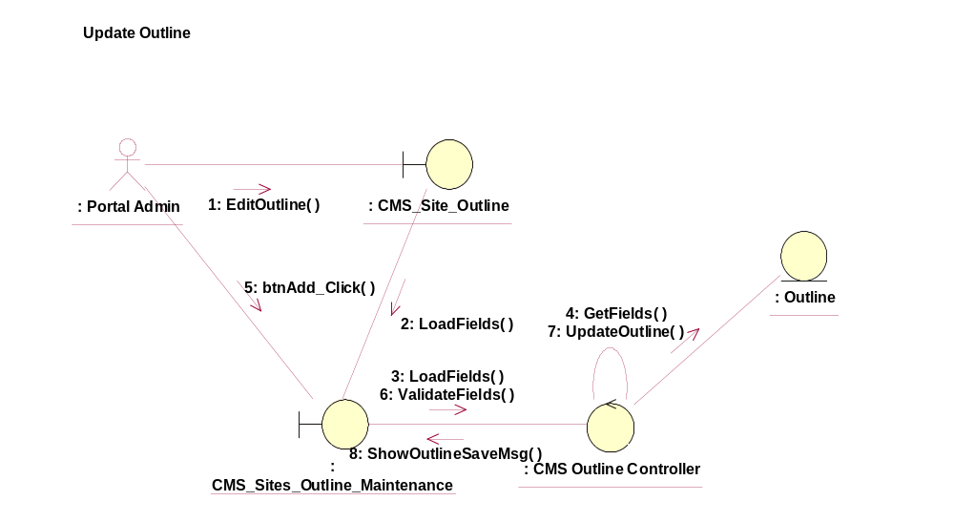

Participating Objects
CMS_Site_Outline
This object will be used for creating the outline.
: CMS_Sites_Outline_Maintenance
This object will be used for creating/updating/deleting and viewing outlines by portal admin.
: CMS Outline Controller
This is the controller to validate the files and duplicate check and creation of the outline..
: Outline
This is the object to store the outline info.

Class Diagrams

Class Diagram for Update Outline
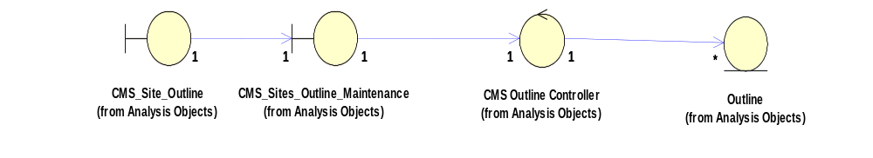

Derived Requirements
[enter the derived requirements here]

